Boosting pea crop productivity: Insights into bio-inoculation and fertilization

Francisco Guevara-Fernández^{1*}, Manuel Oliva-Cruz^{1,2}, and Flavio Lozano-Isla^{1,2}

¹Instituto de Investigación para el Desarrollo Sustentable de Ceja de Selva (INDES-CES), Universidad Nacional Toribio Rodríguez de Mendoza de Amazonas, Chachapoyas, Chachapoyas, 01001, Peru.
²Facultad de Ingeniería y Ciencias Agrarias, Universidad Nacional Toribio Rodríguez de Mendoza de Amazonas (UNTRM), Amazonas 01001, Peru.
*Corresponding author: elen.guevara@untrm.edu.pe.

ABSTRACT

Pea (Pisum sativum L.) is a highly important crop in Peru, playing a crucial role in food security and the agricultural economy of the country. Therefore, it is necessary to improve its performance using promising sustainable agricultural practices such as bio-inoculation and balanced fertilization. The objective of this study was to test the effect of bio-inoculation on pea seed germination under simulated water stress in the laboratory and also to demonstrate the effect of bio-inoculation of pea seeds at two fertilization rates under field conditions. The research was carried out in two phases: in the laboratory, the effects of bio-inoculation and water stress with polyethylene glycol (PEG) on germination, biomass, and seed weight were evaluated, while in experimental plots in the field, the combined effects of bio-inoculation and fertilization on crop yield were investigated. In the laboratory assay, Amysub bioinoculant had a significant effect on seed germination percentage under water stress of -0.4 MPa (p<0.05); in the field, Amysub inoculant also had an effect on seed emergence, and no significant differences were found in pea yield between 100% and 75% of the fertilization dose plus bioinoculant (p>0.05). These results suggest that using seed bio-inoculation, emergence under drought conditions can be improved and the fertilization dose can be reduced by 25% without significantly impacting pea crop yield.

Key words: abiotic stress, biofertilization, PGPM, Pisum sativum L.

INTRODUCTION
The pea (Pisum sativum L.) is an important crop belonging to the Leguminosae family. It is an annual herbaceous crop. It is a high-protein, high-carbohydrate vegetable that is also high in phosphorus, iron, magnesium, calcium, riboflavin, niacin, thiamine, and ascorbic acid (Ramírez-Ojeda, 2016). In Peru, this crop is mostly produced in the inter-Andean Valleys, due to the favorable climatic conditions for its growth. However, this crop faces challenges such as climate change and low yields.
Bio-inoculation is a technique in which plant-growth-promoting microorganisms (PGPM) are used, including bacteria and fungi that promote plant growth and also help suppress pathogens. Species such as Bacillus, Trichoderma, and Pseudomonas are commonly used for these purposes in various crops, providing an eco-friendly alternative. These microorganisms enhance plant vitality by releasing different beneficial metabolites, such as vitamins, amino acids, and growth hormones, into the rhizosphere. They also function as biocontrol agents by fighting diseases through the production of antibiotics, siderophores, hydrogen cyanide, hydrolytic enzymes, and other mechanisms. For this reason, PGPM are combined with materials such as manure, talc, and ash to be used as bio-controllers, bioinoculants, and biofertilizers, thus promoting plant growth and health (Chennappa et al., 2019).
In laboratory experiments, polyethylene glycol (PEG) such as PEG 6000 and PEG 8000 are used as water stress mimicking agents (Raveneau et al., 2011). Water stress can significantly affect seed biomass, weight, and germination by causing decreased imbibition and reduced growth.
In conventional agriculture, excessive fertilization generates economic problems, water eutrophication, imbalances in the soil that harm its fertility (Mateo-Sagasta et al., 2017). Faced with this problem, biofertilization emerges as a biotechnological alternative of ecological and environmental interest, for example (Zavaleta-Verde et al., 2020) conducted studies on the positive effects of Rhizobium, Trichoderma and other growth-stimulating rhizobacteria have been shown to significantly increase the number and weight of nodules, improve nitrogen fixation, and increase the content of macronutrients and micronutrients compared to individual inoculation of Rhizobium sp. (Gonzales Medina, 2013). The effects of bio-inoculation and field fertilization may vary according to management and environmental conditions, which is why it is necessary to validate laboratory results in experimental plots to obtain conclusions that can be applied to agricultural practice.
The objectives of this research were to evaluate the effects of bio-inoculation and PEG 6000 stress on pea seed biomass, weight, and germination. In addition, in experimental field plots, the objective was to demonstrate the combined effects of bio-inoculation and fertilization on pea crop yield components.

MATERIALS AND METHODS
This research had two stages, the first in a laboratory and the second in field conditions. The laboratory stage was carried out at the National University Toribio Rodríguez de Mendoza de Amazonas (UNTRM) in the Plant Physiology and Biotechnology laboratory and the field stage in the towns of Lámud, Luya province, and in Molinopampa, Chachapoyas province, in the Amazonas region of Peru.
Seeds
Pea seeds of the 'INIA-102 Usui' cultivar were obtained with 99% varietal purity, 13% humidity, and 98% germination power. The ‘INIA-102 Usui’ is a semi-erect plant with moderate branching, well-adapted to various growing conditions, including different altitudes and climates, good yield potential and disease tolerance (INIA).
Inoculants tested
Amysub is a consortium of two species of bacteria Bacillus subtilis and B. amyloliquefaciens in concentration ≥1x10⁹ CFU/g, isolated from crop fields on the Peruvian coast. It has antagonistic capacity, prevents and neutralizes the growth of disease-causing fungi (Raúl Yaipén Lab, 2022).
Rizoplant contains Lactobacillus spp.: 1.10x10⁵ CFU/mL, Saccharomyces spp: 2.20x10⁴ CFU/mL, Rhodopseudomonas spp.: 2.30x10⁷ CFU/mL, Streptomyces spp: 2.30x10⁵ CFU/mL, Azotobacter spp.: 3.00x10⁸ CFU/mL, Azospirillum brasilense: 6.50x10⁹ CFU/mL, Bacillus spp.: 6.00x10⁷ CFU/mL, Trichoderma spp.: 2.50x10⁷ CFU/mL, Rizoplant has a pH of 3.5 (Productos Biológicos para la Agricultura, 2024).
Trichops WP is an inoculant and biofertilizer with Trichoderma harzianum, T. viride and T. asperellum in a concentration > 1.5x10¹⁰ conidia/g of Trichoderma spp. It acts as an antagonist and as a bio-stimulant of root growth (Productos Biológicos para la Agricultura, 2024). Some strains of Trichoderma can interact directly with the roots, increasing plant growth potential, disease resistance and tolerance to abiotic stress (Hermosa et al., 2012).
Laboratory phase
In the laboratory, a two-factor experiment was carried out with inoculant (Amysub, Rizoplant, and Trichops) and water stress simulated by PEG 6000 (0 MPa, -0.2 MPa, -0.4 MPa, -0.6 MPa, and -0.8 MPa), the experiment was installed in a Randomized Complete Block Design (RCD) with three repetitions.
Inoculant solutions were also prepared according to the doses of each commercial inoculant product; sterile distilled water was used for this purpose. The seeds of pea var. Usui were surface-disinfected with 70% ethanol for one minute, rinsed and disinfected with 2% sodium hypochlorite for two minutes, and rinsed thoroughly with sterile water four times. The seeds were then separated into four containers and inoculated with three commercial inoculants (Amysub, Rizoplant, and Trichops), while the control was only soaked in distilled water. The seeds were imbibed in the inoculant solutions for 12 hours.
For solutions with PEG 6000, 119.6, 178.3, 223.6 and 261.9 grams of PEG 6000 were dissolved per liter of distilled water to obtain solutions with -0.2 MPa, -0.4 MPa, -0.6 MPa and -0.8 MPa of water potential respectively.
For the test, 30 seeds were germinated in each 20 cm x 12 cm x 5 cm plastic container on two layers of paper towel. Using a syringe, the seeds were moistened with solutions with the following potentials: 0 MPa, -0.2 MPa, -0.4 MPa, -0.6 MPa, and -0.8 MPa. The paper towel and the seeds were initially moistened with 20 ml of each solution and then (on the third day) they were moistened once more with 15 ml of each solution. The water used to prepare the inoculating solutions and the osmotic solutions was distilled water with a pH of 6.94 and an EC of 1.01 microsiemens/cm.
Germination percentage assessments were performed on days 1, 3, 5, and 7, while biomass and weight were assessed on day 7 at the end of the experiment. For biomass, seeds were weighed together with the radicle and plumule, and to obtain weight, only the weight of the radicle and plumule was recorded, for which the seed was removed manually.
Field testing
The fieldwork was conducted in the Amazonas region of Peru, from March to June 2024 in Lámud, province of Luya at 2422 m asl (coordinates: -6.144412°, -77.932590°), and in Molinopampa, province of Chachapoyas from June to September 2024, province of Chachapoyas at 2442 m asl (coordinates: -6.2084 03°, -77.673670°). According to the soil test report, the soil presented a clay texture in both places.
Before the installation of the experiment, a soil fertility analysis study was conducted at the Soil and Water Research Laboratory of the UNTRM, finding chemical characteristics such as 8.42 soil pH, 0.10 dS/m of electrical conductivity, 11.49 ppm of phosphorus, 200.62 ppm of potassium, 1 % of carbon, 1.72 % of organic matter and 0.09 % of nitrogen for Lámud and 5.45 soil pH, 0.34 dS/m of electrical conductivity, 16.61 ppm of phosphorus, 461.16 ppm of potassium, 2.8 % of carbon, 4.83 % of organic matter and 0.24 % of nitrogen in Molinopampa.
Conducting the experiment
In the experimental field plots, 30 seeds were sown in each 3 m furrow, spaced 10 cm between plants. The pea crop had a vegetative period of 96 days in Lámud and 119 days in Molinopampa from planting to harvesting; during this time all variable evaluations were carried out. Irrigation was done manually in both places, and fertilization was carried out localized with nitrogen and phosphorus 20 days after planting, for fertilization, the application of the treatment doses in the experimental units was taken into account (Table 1). 100% of the dose comprised 150 kg/ha of nitrogen, 48.5 kg/ha of phosphorus, and 120 kg/ha of potassium. The sources of nitrogen and phosphorus used included urea (46-0-0) and diammonium phosphate (18-46-0).
Crop management
The soil was prepared using an agricultural tractor, and then the experimental plots located in a randomized complete block design were arranged owing to terrain slope. Subsequently, soil sampling was carried out at a depth of 20 cm using the Scheweizer methodology (Schweizer, 2011) and then taken to the laboratory for fertility analysis.
Planting was carried out in March 2024 in Lámud and June in Molinopampa, planting density was 0.70 m between rows and 0.1 m between plants, the seeds were located at 5 cm depth. Due to the lack of rainfall, manual watering was applied in both places, in Lámud 5.95 m³.ha⁻¹ in five events (March 21, April 25, May 13, 20 and 27).
A trellis-type tutoring system was installed using posts, wire and polypropylene raffia to keep the plants erect. Field evaluations of aphids (Aphis sp.) and crickets in the experimental plots were carried out (Rodriguez et al., 2022) and phytosanitary control was applied promptly to avoid damage caused by crickets in Molinopampa and aphids in Lámud, for which it was used cypermethrin (Serfi) only once because there was no need for a second treatment. No fungicides were used to avoid possible interactions with the inoculants.
Two manual weed control was practiced (30 and 45 dap), and fertilizer was applied 20 days after planting (dap), making holes 15 cm from the plant. Hilling was carried out manually 45 dap in both places.
In Lámud the first harvest was done at 78 dap, the second at 84 dap, and the third at 96 dap. Whereas in Molinopampa, the first harvest was done at 94 dap, the second at 106 dap, and the third at 119 dap.
Evaluations
In the field, the percentage of seed emergence was evaluated by counting, 10 days after sowing.
In Lámud, at 24 das, the incidence and severity of aphids was evaluated (Rodriguez et al., 2022), for which the presence and number of aphids per plant was recorded. In Lámud and Molinopampa, the number of days from sowing to flowering of 50% of the plants were recorded.
During the flowering phenological stage, plant height was measured with a measuring tape from the neck to the apex of the plant. At this stage, nodulation was also evaluated, for which two plants were randomly selected from each experimental plot and the number of nodules was counted. These were then dried in an oven and weighed.
Evaluation of the yield variables, four plants were marked with raffia and harvested from each row (8 plants per experimental unit), from which the number of pods per plant was counted and the average weight of the green pods was recorded. To determine the weight of the pods at harvest, a 5000 gx 1 g electronic scale was used.
Data analysis
Data analysis was performed using R software (R Core Team, 2024). To verify data behavior, the procedure recommended by Kozak & Piepho (2018) was followed. In this way, the normality and homogeneity of variances were verified in the residuals of the analysis of variance model using diagnostic graphs. For normality and analysis of variance (ANOVA), the stats library was used. For homogeneity of variances, was used the car library. To find simple effects, the emmeans library was used. For the variables that met the assumptions of the analysis of variance, multiple comparisons were made using Duncan by the agricolae library and for the variables that did not meet any assumption, the Kruskall-Wallis test was performed with the stats library.

RESULTS
Effect of bio-inoculation and water stress on pea seeds
Inoculation of pea seeds with plant growth-promoting microorganisms improved germination parameters of pea seeds under water stress at the laboratory level.
It was found that 7 days after sowing, the analysis of variance showed significant differences for the interaction between the inoculant and water stress for the biomass variable, so the simple effects were analyzed at each of the levels (Figure 1). Seeds inoculated with Amysub had greater biomass than those inoculated with Rizoplant and Trichops (p <0.05) subjected to -0.4 MPa of water stress.
Furthermore, the simple effects of water stress levels in each inoculant show that with Amysub at -0.2, -0.4 and -0.6 MPa the same biomass was obtained (p<0.05) despite the water stress simulated by PEG 6000 (Figure 1). While with the Rizoplant and Trichops inoculants there was a difference between -0.2 MPa and -0.4 MPa.
Regarding the variable combined weight of the radicle and plumule of germinated pea seeds, it was found that this was greater with -0.2 MPa of water stress, which was significantly different from the control with distilled water. The germination percentage also showed significant differences for the water stress factor. It can be observed that with the stress level - 0.2 MPa a higher germination percentage was obtained than with the distilled water control (figure 2).
Effect of bio-inoculation and fertilization on yield parameters
In field trials, significant differences were found in the percentage of emergence, in which the Amysub inoculant stood out. In the variable days to flowering, with the Trichops inoculant, the plants flowered in fewer days while in yield no significant differences were found between 75% and 100% of the dose plus bio-inoculation.
The results show that with the Trichops inoculant, fewer days to flowering were obtained in Molinopampa, which differs significantly from the Rizoplant and Amysub inoculants (p<0.05). Regarding the plant height variable in Lámud, the Duncan test at 5% did not show significant differences between 100% of the fertilization dose and 75% of the dose plus inoculant (Figure 3).
The weight of pods did not show significant differences for the treatments with 100% and 75% of the fertilization dose plus inoculant in Lámud, as shown in Figure 4. On the contrary, significant differences were observed (p<0.05) between the treatment without fertilization and the treatments with 75% and 100% of the fertilization dose.
DISCUSSION
In the laboratory test, it was found that pea seeds inoculated with the Amysub bioinoculant obtained greater biomass than the other inoculants at -0.4 MPa of water stress simulated with PEG 6000. In the experimental plots, it was found that with Amysub a higher percentage of emergence was obtained, in addition no significant differences were found for plant height and pod weight between the levels 100% of the dose and 75% of the dose of fertilization plus bio-inoculation.
Bacillus spp. promotes seed germination and emergence
The Amysub inoculant contains Bacillus spp. bacteria, which, as in this study, have been reported to alleviate drought stress in peas by producing ACC deaminase (Saikia et al., 2018). In addition, significant differences were observed in the biomass with respect to Trichops containing Trichoderma spp. It was also found that the greater the simulated stress with the water potential, the biomass of the germinated pea seeds decreased (Sánchez et al., 2004).
In the interaction of the factors it was found that the pea seeds with the Amysub inoculant subjected to -0.4 MPa had the same biomass as those with Rizoplant and Trichops at -0.2 MPa, which indicates that the Amysub inoculant better alleviated water stress.
Regarding the weight of the plumule and radicle on the seventh day, it was found that with the -0.2 MPa treatment the seeds obtained significantly more weight than the control and the other levels of PEG 6000, which suggests that this osmotic potential works as a germination treatment, this result corresponds to that reported by Yanglem et al. (2021) in which with 5% PEG a greater plant height, number of functional leaves and relative water content were obtained and also with Rouhi et al. (2011) who reported better germination at - 0.1 MPa in soybeans.
In the experimental field plots, it was found that seeds inoculated with the Amysub bioinoculant significantly improved the emergence percentage than with Trichops and the uninoculated control. The Amysub bioinoculant seems to have provided better conditions for the germination of pea seeds. Several studies have shown that bioinoculants can improve seedling emergence and growth by providing benefits such as improved nutrient availability and protection against soil pathogens (Aloo et al., 2022).
With seed inoculation, the fertilization dose could be reduced by 25%
The average number of days to flowering in Molinopampa was in accordance with the BBCH 60 - 69 flowering stage, while in Lámud the average was 56 d, mainly due to water stress. With the bioinoculant Trichps, significantly fewer days to flowering were obtained than with Rizoplant and the uninoculated control. This suggests that Trichoderma spp. not only acts as a biological control agent, but can also positively influence the phenological development of plants, accelerating flowering. This effect could be related to the capacity of Trichoderma spp. to induce the production of phytohormones, such as auxins, which play a key role in promoting plant growth and development (Harman et al., 2004).
Regarding plant height, no significant differences were found between the control with 100% of the recommended dose and the treatments with inoculant plus 75% of the dose. This suggests that reducing the fertilizer dose in combination with the use of bioinoculants can maintain growth comparable to the use of the full dose of fertilizer. The lack of significant differences in plant height could indicate that bioinoculants can compensate for the reduction in chemical fertilization by improving nutrient uptake or by stimulating growth through the production of phytohormones (Vessey, 2003). Previous studies have shown that certain bioinoculants, such as those containing plant growth-promoting rhizobacteria (PGPR), can improve nutrient use efficiency, allowing plants to achieve similar growth even with lower amounts of fertilizer applied (Espinosa-Cuéllar et al., 2023; Khandare et al., 2020).
In Lámud, no significant differences were found for the number of nodules and nodule weight as reported by Camarena et al. (2023) using Bradyrhizobium sp. and Bacillus sp. in tarwi, while in Molinopampa no nodules were found in the root samples evaluated at flowering, which may be due to soil acidity, which tends to hinder the formation of nodules and the activity of nitrogen-fixing bacteria (Reyes & Valery, 2007; Zavaleta-Verde et al., 2020).
Similarly, in the average weight of pods per pea plant, no significant differences were observed between the control treatment with 100% of the recommended dose of fertilizer and the treatment with 75% of the fertilization dose supplemented with an inoculant. These results are consistent with previous research that has demonstrated the effectiveness of bioinoculants in maintaining or even improving crop yield with less dependence on chemical fertilizers (Adesemoye & Kloepper, 2009). The application of a combined strategy, which reduces the use of chemical fertilizers in favor of bioinoculants, is not only beneficial for the sustainability of the agricultural system, but can also contribute to the reduction of costs and the minimization of negative environmental impacts associated with the excessive use of fertilizers (Bhardwaj et al., 2014).
The main limitation of this work was the lack of rainfall in the experimental area of Lámud, where during the crop cycle there was a total of 2292.8 m³.ha⁻¹ in rainfall, 29.75 m³.ha⁻¹ was irrigated, totaling 2322.55 m³.ha⁻¹, but according to the National Institute of Agrarian Innovation (INIA) the pea crop requires 3500 to 4000 m3/ha, this could have influenced the effect of bioinoculants on the yield components.

CONCLUSIONS

IAt the laboratory stage, seven days after sowing, the bioinoculant Amysub (Bacillus spp.) was better than Rizoplant and Trichops (Trichoderma spp.) in terms of biomass at -0.4 MPa of water stress simulated with PEG 6000.
In field conditions, Amysub (Bacillus spp.) was superior in terms of percentage of emergence, with the Trichops (Trichoderma spp.) inoculant the plants flowered in fewer days, and no significant differences were found between 100% and 75% of the recommended fertilization dose for the variables plant height, average pod weight and green pod yield per hectare.

Author contribution
Conceptualization: F.G-F. Methodology: F.G-F, F.L.I. Software: F.L-I. Validation: M.O-C. Formal analysis: F.L-I. Investigation: F.G-F. Resources: M.O-C. Data curation: F.G-F. Writing-original draft: F.G-F. Writing-review & editing: F.L-I. Visualization: F.L-I. Supervision: M.O-C. Project administration: M.O-C. Funding acquisition: M.O-C. All co-authors reviewed the final version and approved the manuscript before submission.

Acknowledgements
The authors acknowledge the CUI project N° 2590588 "Mejoramiento del Servicio de Promoción de la Ciencia, Tecnología e Innovación para el Centro de Investigación en Granos y Semillas" – CEIGRAS, Instituto de Investigación para el Desarrollo Sustentable de Ceja de Selva (INDES-CES), for providing funding and assistance for the development of the research.

Conflict of interest
The authors declare no conflict of interest.
References
Adesemoye, A.O., & Kloepper, J.W. (2009). Plant–microbes interactions in enhanced fertilizer-use efficiency. Applied Microbiology and Biotechnology, 85 (1), 1–12. https://doi.org/10.1007/s00253-009-2196-0
Aloo, B.N., Tripathi, V., Makumba, B.A., & Mbega, E.R. (2022). Plant growth-promoting rhizobacterial biofertilizers for crop production: The past, present, and future. Frontiers in Plant Science, 13. https://doi.org/10.3389/fpls.2022.1002448
Bhardwaj, D., Ansari, M.W., Sahoo, R.K., & Tuteja, N. (2014). Biofertilizers function as key player in sustainable agriculture by improving soil fertility, plant tolerance and crop productivity. Microbial Cell Factories, 13 (1), 66. https://doi.org/10.1186/1475-2859-13-66
Camarena, F., Lazo, V., Saravia, D., Huaringa-Joaquín, A., Caycho, P., Quiñones, R., Mostacero, E., & Zúñiga-Dávila, D. (2023). Combination of Bacterial Strains Bradyrhizobium sp. And Bacillus sp. As a Biofertilizer and Biocontroller in the Cultivation of Tarwi (Lupinus mutabilis Sweet) in the Andean Region of Peru. Peruvian Journal of Agronomy, 7 (1), Article 1. https://doi.org/10.21704/pja.v7i1.2002
Chennappa, G., Naik, MK, Udaykumar, N., Vidya, M., Sreenivasa, MY, Amaresh, YS, & Mathad, P.F. (2019). Chapter 10 - Plant growth promoting microbes: A future trend for environmental sustainability. In J. S. Singh (Ed.), New and Future Developments in Microbial Biotechnology and Bioengineering (pp. 163–178). Elsevier. https://doi.org/10.1016/B978-0-12-818258-1.00010-8
Espinosa-Cuéllar, A., Rivera, R., Varela-Nualles, M., & Pérez-Díaz, A. (2023). Mycorrhizal inoculants on sweet potato (Ipomoea batata) in Eutric Cambisol soils of Cuba. Mesoamerican Agronomy, 53725–53725. https://doi.org/10.15517/am.2023.53725
Gonzales Medina, EY (2013). Study of the diversity of Rhizobium strains from nodules of three varieties of common bean (Phaseolus vulgaris L.). http://repositorio.lamolina.edu.pe/handle/20.500.12996/3847
Harman, GE, Howell, CR, Viterbo, A., Chet, I., & Lorito, M. (2004). Trichoderma species—Opportunistic, avirulent plant symbionts. Nature Reviews Microbiology, 2 (1), 43–56. https://doi.org/10.1038/nrmicro797
Hermosa, R., Viterbo, A., Chet, I., & Monte, E. (2012). Plant-beneficial effects of Trichoderma and of its genes. Microbiology, 158 (1), 17–25. https://doi.org/10.1099/mic.0.052274-0
Khandare, R.N., Chandra, R., Pareek, N., & Raverkar, K.P. (2020). Carrier-based and liquid bioinoculants of Azotobacter and PSB saved chemical fertilizers in wheat (Triticum aestivum L.) and enhanced soil biological properties in Mollisols. Journal of Plant Nutrition, 43 (1), 36–50. https://doi.org/10.1080/01904167.2019.1659333
Kozak, M., & Piepho, H. ‐P. (2018). What's normal anyway? Residual plots are more telling than significance tests when checking ANOVA assumptions. Journal of Agronomy and Crop Science, 204 (1), 86–98. https://doi.org/10.1111/jac.12220
Mateo-Sagasta, J., Marjani, S., & Turral, H. (2017). Water pollution from agriculture: A global review - Executive summary. FAO https://openknowledge.fao.org/handle/20.500.14283/i7754en
Productos Biológicos para la Agricultura. (2024). Pba.pe: Biological Products for Agriculture. https://pba.pe/
R Core Team. (2024). R: A language and environment for statistical computing. R Foundation for Statistical Computing. https://www.R-project.org/
Ramírez-Ojeda, 2016. Peas and lentils. In The Encyclopedia of Food and Health (pp. 283-288). Elsevier
Raúl Yaipén Lab. (2022, May 27). Better formulation of agrochemicals in Peru. Raúl Yaipén Lab. https://raulyaipen.com/
Raveneau, M.P., Coste, F., Moreau-Valancogne, P., Lejeune-Hénaut, I., & Durr, C. (2011). Pea and bean germination and seedling responses to temperature and water potential. Seed Science Research, 21 (3), 205–213. https://doi.org/10.1017/S0960258511000067
Reyes, I., & Valery, A. (2007). Effect of soil fertility on microbiota and growth promotion of corn (zea mays l.) with azotobacter spp. Bioagro, 19 (3), 117–126.
Rodriguez, AV, Ruiz, RE, David, ENE, & Albornoz, MEC (2022). Integration of the components of Integrated Pest Management in the cultivation of Pisum sativum in the Huánuco region, Peru. Enfoque UTE, 13 (3), 58–68.
Rouhi, HR, Surki, AA, Sharif-Zadeh, F., Afshari, RT, Aboutalebian, MA, & Ahmadvand, G. (2011). Study of Different Priming Treatments on Germination Traits of Soybean Seed Lots. Notulae Scientia Biologicae , 3 (1), 101–108. https://doi.org/10.15835/nsb315462
Saikia, J., Sarma, R.K., Dhandia, R., Yadav, A., Bharali, R., Gupta, V.K., & Saikia, R. (2018). Alleviation of drought stress in pulse crops with ACC deaminase producing rhizobacteria isolated from acidic soil of Northeast India. Scientific Reports, 8 (1), 3560. https://doi.org/10.1038/s41598-018-21921-w
Sánchez, FJ, de Andrés, EF, Tenorio, JL, & Ayerbe, L. (2004). Growth of epicotyls, turgor maintenance and osmotic adjustment in pea plants (Pisum sativum L.) subjected to water stress. Field Crops Research, 86 (1), 81–90. https://doi.org/10.1016/S0378-4290(03)00121-7
Schweizer S. (2011) Soil sampling and analysis for fertility diagnosis. Available at: http://www.mag.go.cr/bibliotecavirtual/P33-9965.pdf
Vessey, J. K. (2003). Plant growth promoting rhizobacteria as biofertilizers. Plant and Soil, 255 (2), 571–586. https://doi.org/10.1023/A:1026037216893
Yanglem, S.D., Ram, V., Rangappa, K., Premaradhya, -, & Deshmukh, N. (2021). Effects Of Seed Priming On Root- Shoot Behavior And Stress Tolerance Of Pea (Pisum Sativum L.). Bangladesh Journal of Botany, 50 (2), Article 2. https://doi.org/10.3329/bjb.v50i2.54074
Zavaleta-Verde, D., Soriano, B., & López, M. (2020). Inoculant consisting of Rhizobium leguminosarum, Burkholderia ubonensis and Trichoderma harzianum increases the number of active sites for nodulation of Pisum sativum. Manglar, 17 (1), Article 1.
Tables and figures
Table 1. Description of treatments
Treatment | Code | Description
Treatment 1 | Control | No inoculation, 100% dose
Treatment 2 | T2 | Amysub, no fertilization
Treatment 3 | T3 | Amysub, 75% of the dose
Treatment 4 | T4 | Rhizoplant, no fertilization
Treatment 5 | T5 | Rizoplant, 75% of the dose
Treatment 6 | T6 | Trichops, no fertilization
Treatment 7 | T7 | Trichops, 75% of the dose
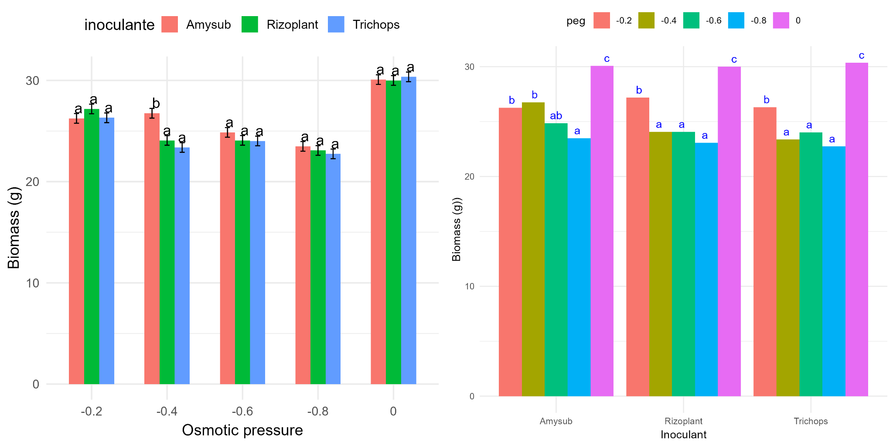
Figure 1. Simple effects on the biomass variable of the inoculant levels at each osmotic pressure level (left) and of the osmotic pressure levels at each inoculant level (right) (p<0.05)
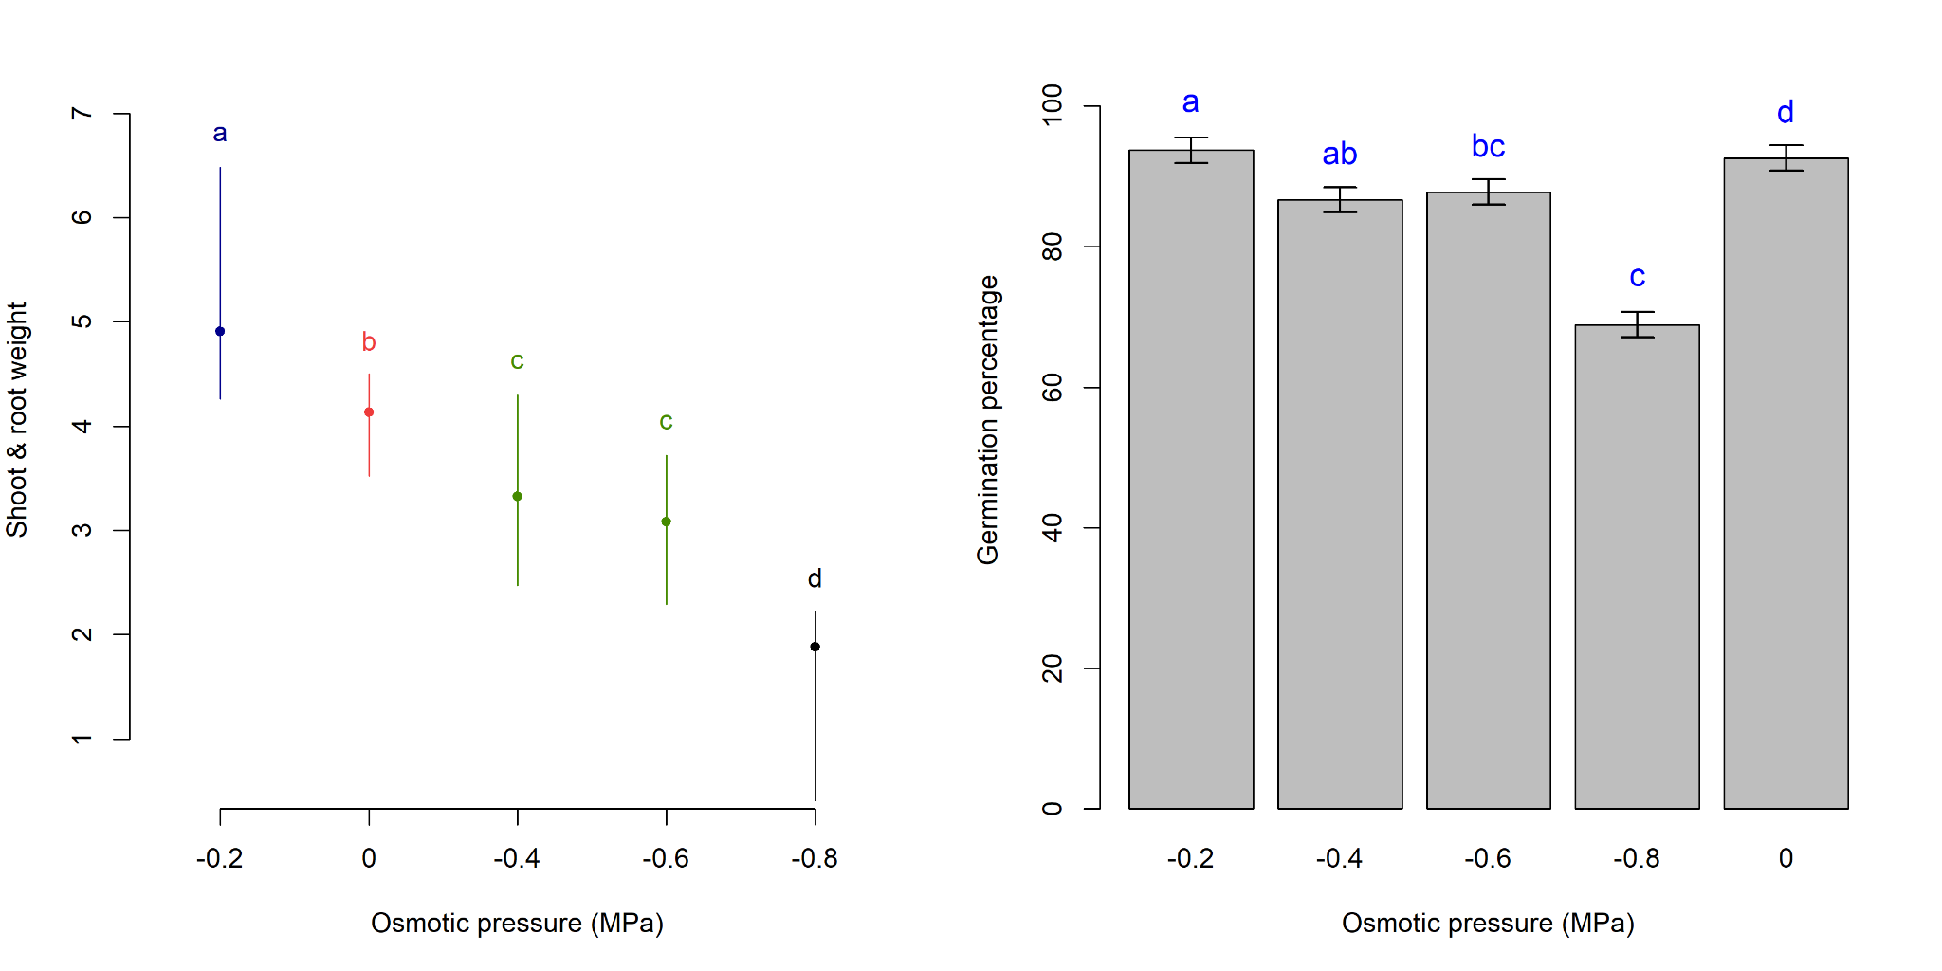
Figure 2. Plumule and radicle weight (left) and germination percentage (right) according to osmotic pressure. Significant differences according to Duncan test (p<0.05)
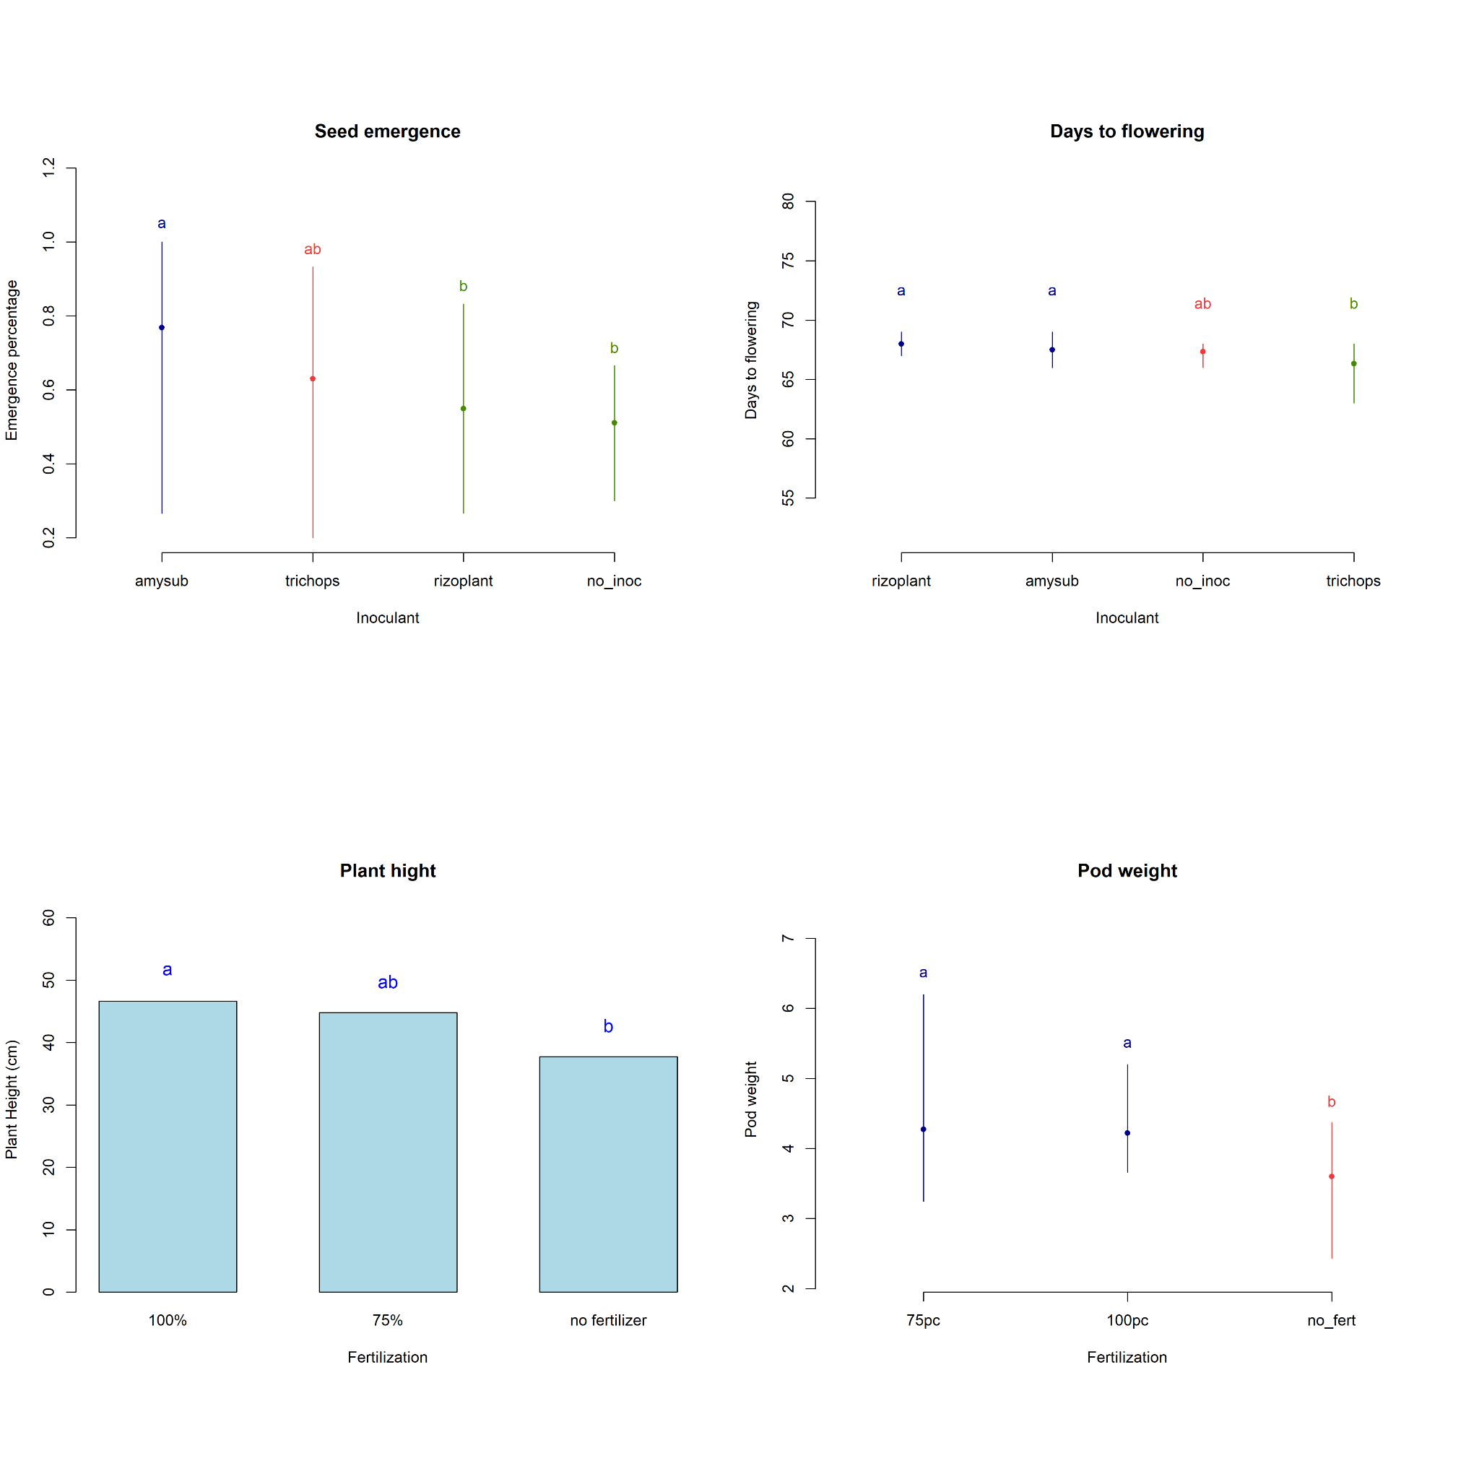
Figure 3. Percentage of seed emergence, days to flowering, plant height, and pod weight in pea (Pisum sativum L.), according to Duncan test (p<0.05)

